Collections for October 2nd $2650.46

Helping Hands Food Bank Really Needs Your Help
Helping Hands here in Kennett has almost nothing to give to the poor and hungry in our area at this time. Please bring any non-perishable food items to church and Beth Johnson will be sure to get them to the food bank. You may also drop by Helping Hands and bring your gift in person. Please consider picking up something this week to help the most vulnerable in Kennett.

PSR Classes
These classes are for anyone seeking the sacraments of First Communion or Confirmation. We have parent classes at the same time as the children’s classes, which is 11:45am on Sundays.

World Mission Sunday
World Mission Sunday will be 10/23/22. Envelopes are in the Church Foyer. Please be generous in donating to the mission work through The Society for the Propagation of the Faith.

Delta Fair
A special thank you to all those who participated in the St. Cecilia booth at the Delta Fair. It was a huge fundraising success.

Mother’s House
The monthly Mother’s House collection for October will be this Sunday, October 9th, due to the missionary collection we had last weekend.

Father David’s Schedule
Father David will attend a Priest’s Institute this week, Oct 10th through Oct 14.
Week day masses and adoration will be canceled this week.

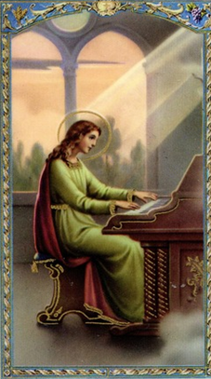
October 9, 2022
Twenty-seventh Sunday in Ordinary Time

St. Cecilia Catholic Church
1226 College Avenue PO Box 306
Kennett, MO 63857
www.stceciliakennett.com

Fr. David Baunach, Pastor
417-851-7136 davidbaunach@gmail.com
Luis Hernandez, Hispanic Ministry (417) 496-5622
Joanie DeLisle, Bookkeeper/Secretary
Vanessa Cowart, PSR Director (561) 351-1380
Magda Cazares, Youth Group Director

Fr. David’s Parish Office Hours:
Kennett: Monday and Wednesday 10-4, Portageville: Thursday and Friday 10-4

Fr. David is available for the Sacrament of Reconciliation during Adoration or by appointment.

Holy Mass Schedule
Monday and Wednesday: Adoration at 5: Mass at 6pm
Sunday Masses: 10:30am Mass in English; 10:05am Rosary
1pm Mass in Spanish

Please pray for /Oramos para:
+Lynette Anderson, +Pedro Orocio, The Melendez Family, James Hargett,
+Sandy DeLisle, +Bill Anderson, Polly McAtee, Bob and Sharon Hines, Vera Gleuck, and Kathy Larsen. Especially let us remember Bishop Rice, Fr. David, and our homebound.

Mass Intentions
October 9 +Bob Bradley
October 12 Health and Wellbeing of Mary Saracini
October 16 +Greg Bradley

MEET SOME OF THE CAST OF “A FESTIVAL OF HYMNS”

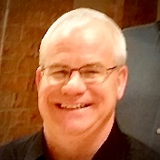
PERCUSSION: Michael Cates began playing drums professionally at age 14 with The Jones Family, a Southern Gospel Group from West Tennessee. After high school Michael graduated from Union University in Jackson Tennessee where he studied music with Marilyn Honeycutt, Joe Haynes and Nancy Matheson. Michael also studied drum set with Ed Soph. Michael has been a member of the Dyersburg Community Orchestra, Germantown Symphony Orchestra in Memphis, Tennessee and has played in various groups around the West Tennessee, Western Kentucky and Southeast Missouri area for over 40 years. Michael taught instrumental music for 15 years in West Tennessee and Southeast Missouri and earned a Doctorate in Educational Leadership from William Woods University. Michael is currently the School Counselor at Caruthersville Middle School in Caruthersville, Missouri.

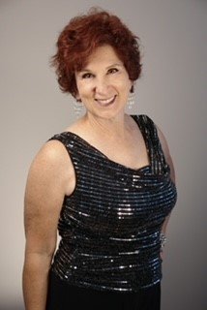
ALTO SOLO: Amalia LaViolette has been performing all her life and holds a BME from the University of Nebraska-Lincoln (vocal major/piano and dance minors). She spent 8 seasons as an alto section leader with the St. Louis Symphony Chorus, performing twice at Carnegie Hall, and making her solo debut with the Symphony in 1996. She has won four Arts for Life Awards for musical theatre in the St. Louis area, and books for and sings with several professional groups. She is involved in animal rescue and loves to travel mutually in our lovely country and internationally. Amalia was able to combine both while volunteering with greyhound rescue in Spain. Consequently, she and her husband have a beautiful, retired racer named Boreas (Greek god of the North Wind). They also have two grown children; one is a chef working in Copenhagen and one has a Masters in Entomology, is married, and lives in Phoenix.
.
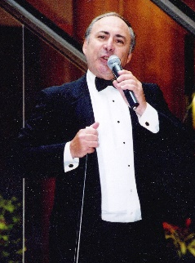
BARITONE SOLO: Ed Golterman comes to Kennett fresh from celebrating a lifetime of rendering music—sacred, patriotic, Broadway and pops in his Ed Comes Home cabaret last month. Ed sang with Mario Salvador’s St. Louis Cathedral Choirs, SLU High and Saint Louis University choirs and headlined at Kiel Opera, the Arena and the National Anthem on the ice before more than 600 Blues hockey games. He has sat on the same stage with Bob Hope, Grace Bumbry, Franco Corelli, and many of the performers on this stage in shows and concerts. Ed’s mother, Maria, was an accomplished opera singer, his grandfather, Guy Golterman was the famous Impresario who brought Grand Opera to the Kiel and to both coasts, and his brother Jim, a tenor, was soloist and section leader in the U.S. Army Chorus for nearly 30 years. Blessings abound here this weekend, and for Ed, a salute to his brother who has also ‘come home’.

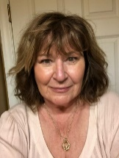
MISTRESS of CEREMONIES: Eileen Crain, married to Randall Crain, have two children and six grandchildren. She retired from 30 years at UPS as an operations division manager. In addition to overseeing management of over 1,000 employees, Eileen spent much of her time in public speaking engagements with either training or corporate presentations. Her Master Operating Plan for running call centers and presented to the Board of Directors was placed in over 50 call centers and continues today. Eileen is not all work and no play, she is a Baseball afficionado, having visited nearly all the MLB parks to cheer both the Cardinals and Royals

CONDUCTOR/TRUMPET: Joe Paule retired from 30 years of teaching band but continues to be involved in Community bands and theater. He taught in the Ferguson/Florissant Sch. Dist. at Cross Keys Middle School and assisted with the McCLuer North High School’s Marching Band and Musicals. He is lead trumpet with the Northwinds Community Band in Florissant and performs with the 18-piece Sentimental Journey Big Band. As of July 2019, Joe conducts the yearly VP Parade Circus Band Wagon Float in St. Louis. In 1974, Joe began playing and conducting for numerous theater groups which include, The Marquee Players, Glennon Players, Hawthorne Players, Alpha Players, Christ Memorial Lutheran, Family Musical Theater, Kirkwood Theater Group, Bravo Theater Group, Studio J Productions, and Center Stage Productions. Add to this list the many years of high school shows, such as, McCluer, McCluer North, Ritenour, Notre Dame, Nerinx Hall, Villa Duchesne, Incarnate Word, CBC, and youth theaters of Gateway Center For Performing Arts and St. Charles Community Youth Theater. Conducting favorites include The Producers, Man Of La Mancha, Once Upon A Mattress, Oklahoma, Over Hear, A Chorus Line, 42nd Street, Crazy For You, Pippin, Lil’ Abner, Damn Yankees, Annie, Bye Bye Birdie, Camelot, West Side Story, Joseph…Dreamcoat, and Jesus Christ Superstar to name of few .Joe has conceived and arranged two of “The Best Of Hawthorne” shows that raise money for high school senior scholarships to study theatre arts---Cowboy Swing and Cowboy Christmas. In 2020, Joe was presented the ARTS FOR LIFE Lifetime Achievement Award.

This is just a sampling of the many performers, technicians and talent for A Festival of Hymns and Sacred Songs November 11, 12, and 13—6pm Friday; 2pm and 6pm Saturday, and 1pm Sunday. More bios to come and the visiting choirs from local churches are to be announced.

VOLUNTEERS:
We really need your help for some of the following:
- Distribute posters and hand outs in local businesses
- Help with marketing
- Organize ticket sales: $10 Open rehearsal; $20 concert tickets; $25 concert tickets at the door. All general admission
- Help with T-Shirt sales and pre-ordering.
- Help and organize dinner on Friday between Open Rehearsal and 6pm show and between shows on Saturday.
- Stage crew to move furniture from Altar and reset after the concerts
- Help organize and work valet parking ($5 Valet Parking; FREE Valet Parking for cars with disability indicators).
- Need Ushers and Traffic Controllers in the parking lot
- Volunteers to house out of town performers
- Box Office helpers
- People wranglers at the performances
- WE NEED A SOUND ENGINEER!!!!! We’ve had several scheduled only to loose them to emergencies.
- Need people to call radio, printed media and TV for PSAs and interviews
- Call groups who might want to attend open rehearsal for half price—seniors, disabled and companions.

Call Lucinda at 314-640-8105 if you can help or have more suggestions or would like to sing with our choir.

